SUPPLEMENTARY MATERIAL
A. List of variables available for analysis
Baseline: Age (<65, >=65 years old), Region (US, Europe, Rest of world), Gender, ECOG status, Histology (MF, SS), Disease stage, Best response to last CTCL therapy, CCR4 Expression Status, LDH category, Time from initial diagnosis, number of prior CTCL therapies, prior radiotherapy
Time-dependent: Progressed disease, adverse events (any), adverse events (grade 2+)
B. Methodology to fit survival curves
Separate parametric models were fit to each treatment arm. The following parametric models were explored: exponential, Weibull, log-normal, log-logistic, gamma, generalised gamma, and Gompertz.
Selection of the base case parametric model was based on standard criteria used by Health Technology Assessment agencies(22):
- Objective statistical measures of goodness of fit to observed KM data: Akaike information criterion and Bayesian information criterion statistics;
- Visual inspection of goodness of fit to observed KM data, and diagnostic plots, including the log-cumulative hazard plots
- Clinical plausibility of extrapolations beyond observed KM data, assessed through structured interviews with leading NHS consultants experienced with the treatment and care of MF and SS patients in an NHS England setting
C. IPCW extra detail: Weights
Figure 1 shows the weights applied in the IPCW analysis for step 3. There were a small number of extreme weights.
Figure 1: Histogram of weights from the IPCW analysis

The profile of weights over time are shown in Figure 2.
Figure 2: Plot of weights over time from the IPCW analysis

D. ITT population
The OS HR for mogamulizumab compared to vorinostat without adjustment for crossover was 1.06 (CI 0.75, 1.49). Median OS was 58.37 months in the vorinostat arm and 57.17 months in the mogamulizumab arm. The unadjusted Kaplan Meier curve is included in Figure 3a.
Findings for the ITT population are consistent to those for the advanced population.
RPSFTM
The OS HR for mogamulizumab compared to vorinostat was 1.23 (CI 0.87, 1.74). Median OS was 71.24 months in the vorinostat arm and 51.17 months in the mogamulizumab arm. As with the advanced population, the common treatment effect assumption was not considered to be satisfied.
IPCW
When the weights detailed above were applied to the ITT population, the central HR after adjusting for crossover using IPCW was 0.53 (CI: 0.24, 1.16) for mogamulizumab compared to vorinostat. Median survival in the vorinostat arm was 45.67 months in the unadjusted analysis, and fell to 27.07 months in the IPCW-adjusted analysis. The Kaplan Meier curves have been included in Figure 3b. The method produces a visible drop in the numbers at risk as participants are censored from the analysis after the crossover is allowed after two full cycles of treatment.
TSE
When the weights detailed above were applied to the ITT population, the central HR after adjusting for crossover using TSE was 0.71 (CI: 0.50, 1.01) for mogamulizumab compared to vorinostat. Median survival in the vorinostat arm was not reached in the unadjusted analysis, which fell to 41.93 months in the TSE-adjusted analysis. The Kaplan Meier curves have been included in Figure 3c.

Figure 3 Kaplan Meier curves ITT population, a) adjusted for crossover with IPCW; b) adjusted for crossover with TSE
a)
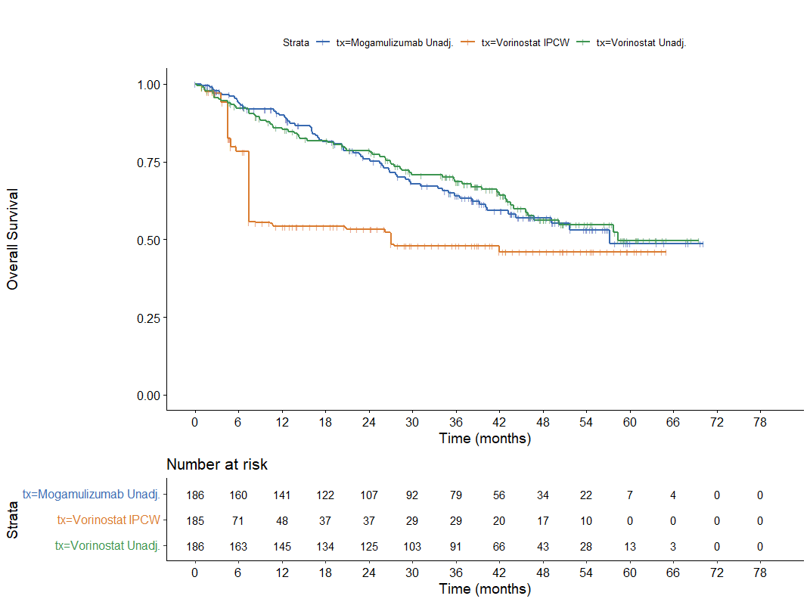
b)
